NOTICE OF PUBLIC MEETING
JAMES AVE. NE STREET RECONSTRUCTION

Re: Open House for the Grading and Paving project proposed for James Avenue NE from 120th Street NE to approximately 380 ft south of the intersection of Skyview Drive NE.

An open house will be held at the Shueyville Community Center on Thursday,
March 30th from 5:30 to 7:00 p.m. concerning the proposed reconstruction of James Avenue NE. The Shueyville Community Center is located at 2863 120th Street NE in Shueyville.

Preliminary construction plans and other pertinent information developed for the project will be available for viewing. Engineering staff from Veenstra & Kimm, Inc. will be available to answer questions and record any comments and/or concerns prior to developing the final plans for the project. The format of the open house is informal. You are invited to come and go any time between 5:30 and 7:00 p.m. No formal presentation is planned.

If you have any questions or comments regarding the project please contact Dave Schechinger, Project Engineer, at 319-466-1000.

Sincerely,
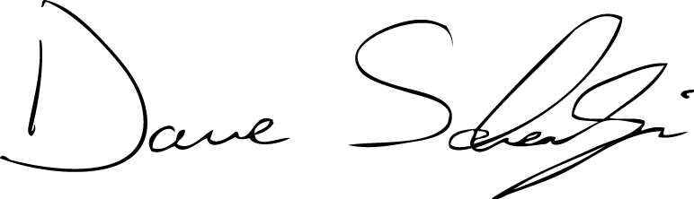

David R. Schechinger, P.E.
Project Engineer

