AMENDMENT #3

to the

SHUEYVILLE 2003 URBAN RENEWAL PLAN

for the

SHUEYVILLE 2003 URBAN RENEWAL AREA

CITY OF
SHUEYVILLE, IOWA

Original - 2003
Amendment #1 - 2007
Amendment #2 – 2009
Amendment #3 – 2016

SIMMERING-CORY, INC.

AMENDMENT #3
to the
SHUEYVILLE 2003 URBAN RENEWAL PLAN
for the
SHUEYVILLE 2003 URBAN RENEWAL AREA
CITY OF SHUEYVILLE, IOWA

The Shueyville 2003 Urban Renewal Plan (“Plan” or “Urban Renewal Plan”) for the Shueyville 2003 Urban Renewal Area (“Area” or “Urban Renewal Area”), adopted in 2003 and amended in 2007 and 2009 is being further amended to add additional land to the Urban Renewal Area and to add and/or confirm the list of proposed projects to be undertaken within the Urban Renewal Area by this Amendment #3 (“Amendment #3” or “Amendment”).
Except as modified by this Amendment, the provisions of the Urban Renewal Plan, as previously amended, are hereby ratified, confirmed, and approved and shall remain in full force and effect as provided herein. In case of any conflict or uncertainty, the terms of this Amendment shall control.
DESCRIPTION OF THE URBAN RENEWAL AREA
The legal description of the property being added by this Amendment #3 is attached hereto as Exhibit “A.” A map of property being added by this Amendment #3 is attached hereto as Exhibit “B.” A map of the entire Urban Renewal Area, as amended, is attached hereto as Exhibit “C.”
AREA DESIGNATION
The Urban Renewal Area was originally designated as an economic development area appropriate for commercial and residential developments. Amendments #1 and #2 designated areas in which blighted conditions exist and that are appropriate for the remediation of blight and deterioration.
As a result, the Urban Renewal Area, as amended, continues to be a mixed area in which slum and blight conditions exist, as well as an economic development area that is appropriate for commercial and residential development. This Amendment makes no change to the Urban Renewal Area designation.
BASE VALUE
The original Urban Renewal Area and each amendment area may be referred to as subareas in this Amendment. The property added by this Amendment is called the “Amendment #3 Area.” The subareas make up the Urban Renewal Area. Each of the existing subareas has a frozen base value that has already been established, if a TIF ordinance has been adopted on property in each subarea. Nothing in this Amendment affects already established frozen base values.
Property being added by Amendment #3 to the Urban Renewal Area consists solely of publicly owned right-of-way. As such, the Amendment #3 Area will not be included in a Tax Increment Finance (TIF) ordinance because the land to be added by this Amendment contains no taxable property.
DEVELOPMENT PLAN
Shueyville has a general plan for the physical development of the City, as a whole, outlined in the City of Shueyville Land Use Plan, 2008-2028, adopted in 2008. The goals and objectives of this Urban Renewal Plan, as amended, and the projects proposed therein, are in conformity with the land use policies identified in the City of Shueyville Land Use Plan, 2008-2028.
This Urban Renewal Plan, as amended, does not in any way replace the City’s current land use planning or zoning regulations process.
The need, if any, for improved traffic, public transportation, public utilities, recreational and community facilities, or other public improvements within the Urban Renewal Area are set forth in this Plan, as amended. As the Area continues to develop, the need for public infrastructure extensions and upgrades will be evaluated and planned for by the City.
PLAN OBJECTIVES
Renewal activities are designed to provide opportunities, incentives and sites for community economic development purposes, including new and expanded commercial and residential development, as well as revitalization and alleviation of blighting conditions. Objectives include:
- To stimulate, through public action and commitment, private investment in new development, including commercial and residential housing projects.

- To provide for the installation of public works and facilities which remediate blight and contribute to the sound development of the entire City.

- To provide incentives and implement programs to mitigate blighted conditions and promote revitalization in the commercial and residential districts.

- To eliminate blighting influences and to promote revitalization in the blighted areas.

- To provide a more marketable and attractive investment climate.

- To provide and upgrade public facilities, recreational opportunities, and services that help to improve the quality of life and enhance the overall viability of the community.

- To help develop a sound economic base that will serve as the foundation for future growth and development.

- To plan for and provide sufficient land for commercial and residential development in a manner that is efficient from the standpoint of providing municipal services.

- To preserve the health, safety, living environment, and the general character, and welfare of Shueyville, Iowa.
TYPES OF RENEWAL ACTIVITIES
To meet the objectives of this Urban Renewal Plan, as amended, and to encourage economic development, revitalization, and the alleviation of blight within the Area, the City intends to utilize the powers conferred under Chapters 403 and Chapter 15A, Code of Iowa. Activities may include:
- To undertake and carry out urban renewal projects through the execution of contracts and other instruments.

- To demolish structures and to clear the land for future development so as to revitalize the Area and alleviate blighting conditions.

- To arrange for or cause to be provided the construction of public infrastructure improvements including streets, water and sewer systems, public utilities or other facilities or physical improvements in connection with urban renewal projects which serve to promote development, revitalize the Area, and alleviate blighting conditions.

- To provide for the construction of specific site improvements, such as grading and site preparation activities, access roads and parking, traffic signals, sidewalks and other walkways, storm water management, fencing, utility connections, and related activities.

- To borrow money and to provide security therefor.

- To acquire property through a variety of means (purchase, lease, options, etc.) and to hold, clear, or prepare the property for redevelopment.

- To acquire or dispose of property.

- To make loans, forgivable loans, rebates, or other types of grants or incentives to private persons, businesses, or organizations for economic development projects, revitalization, or blight remediation purposes, including housing projects, on such terms as may be determined by the City Council.

- To finance programs or projects which will directly benefit housing conditions and/or increase the availability of single-family and multi-family housing opportunities for residents of the community.

- To make or have made surveys and plans necessary for the implementation of the Urban Renewal Program or specific urban renewal projects, including economic development projects.

- To use any or all other powers granted by the Urban Renewal Act to develop and provide for improved economic conditions for the City of Shueyville and the State of Iowa.
Nothing herein shall be construed as a limitation on the power of the City to exercise any lawful power granted to the City under Chapter 15, Chapter 15A, Chapter 403, Chapter 427B, or any other provision of the Code of Iowa in furtherance of the objectives of this Urban Renewal Plan, as amended.
PREVIOUSLY AUTHORIZED URBAN RENEWAL PROJECTS
An Urban Renewal Project was authorized prior to this Amendment #3, and is continuing. The previously authorized project was the reconstruction of 120th Street that was financed through a 28E Agreement with Johnson County. This project is complete but $650,000 of debt remains to be paid and is anticipated to be retired in June 2019.
ELIGIBLE URBAN RENEWAL PROJECTS (AMENDMENT #3)
In addition to previously authorized projects, the eligible urban renewal projects under this Amendment #3 include:
- Public Improvements:
Project | Estimated Date | Not to Exceed Cost | Rationale
James Avenue South Reconstruction  Replacing seal coat roadway with pcc roadway from 120th Street south to the City limits. | 2017-2020 | $1,400,000 | The City has limited growth south of James Avenue due to the condition of the existing roadway. The area to the west of James Avenue has the potential for commercial growth but needs an improved road for better access.
Deen Street Reconstruction  Replacing seal coat roadway with pcc roadway on Steeple Lane and Deen Street from 120th to Deen Street. | 2017-2020 | $650,000 | Deen Street is the main access road for an older area of the City. Adjacent properties are occasionally flooded due to heavy storm water run-off from the existing road. Improvements may spur growth and eliminate a blighting condition.
Mill Street Reconstruction  Replacing seal coat roadway with pcc roadway from 120th Street to the north side of town. | 2020-2024 | $400,000 | Mill Street is a main access road for an older area of the City. Adjacent properties are frequently damaged by heavy storm water runoff. The existing seal coat street is not in good condition and needs to be reconstructed.
Council Street Reconstruction  Replacing seal coat roadway with pcc roadway from Deen Street to Water Street. | 2020-2024 | $500,000 | Council Street is in poor condition. Its reconstruction will improve access and may stimulate growth for adjacent properties.
Water Street Reconstruction  Replacing seal coat roadway with pcc roadway from Club Road to west of Council Street. | 2020-2024 | $1,000,000 | The Water Street project will allow access and be a future connector to a potential new subdivision. Improvements will allow for two-way traffic and will open the adjacent agricultural area for development.
Curtis Bridge Road Reconstruction  Replacing existing street surface from 120th Street south to City limits. | 2030-2033 | $2,400,000 | Curtis Bridge Road is a primary street connecting to a potential growth area in the City. The condition of the existing road is very poor and hinders new development from occurring.
Club Road Reconstruction  Replacing seal coat roadway with pcc roadway from 120th Street north to City limits. | 2030-2033 | $1,200,000 | Club Road is the primary street for traffic heading north to Cedar Rapids. The existing road surface is in poor condition. Improving the street surface will improve access for existing commercial businesses adjacent to this road and enhance additional commercial growth.
120th Street Reconstruction  Replacing existing street from intersection of 120th Street and Curtis Bridge Road east to City limits. | 2030-2033 | $400,000 | 120th Street is the primary street heading east out of town. The road surface condition is fair but the replacement will become necessary as the road ages. Property east of this project provides potential development sites. Reconstruction of this road will support continued residential growth in the community.
Note: It may be that the above costs will be reduced by the application of state and/or federal grants or programs; cost-sharing agreements with other entities; or other available sources of funds.

- Future Development Agreements: The City expects to consider requests for Development Agreements for projects that are consistent with this Plan, in the City’s sole discretion. Such Agreements are unknown at this time, but based on past history, and dependent on development opportunities and climate, the City expects to consider a broad range of incentives as authorized by this Plan, including, but not limited to, land, loans, grants, tax rebates, public infrastructure assistance, and other incentives. The costs of such Development Agreements will not exceed $500,000 - $1,000,000.

- Planning, Engineering Fees (for Urban Renewal Plans), Attorney Fees, Other Related Costs to Support Urban Renewal Projects and Planning:
Project | Date | Estimated Cost
Fees & Costs | Undetermined | Not to Exceed $75,000
FINANCIAL INFORMATION
1. | July 1, 2015 Constitutional Debt Limit: | $4,055,611
2. | Outstanding General Obligation Debt: | $250,000
3. | Proposed amount of indebtedness to be incurred: A specific amount of debt to be incurred for the Eligible Urban Renewal Projects (Amendment #3) has not yet been determined. This document is for planning purposes only. The estimated project costs in this Plan are estimates only and will be incurred and spent over a number of years. In no event will the City’s constitutional debt limit be exceeded. The City Council will consider each project proposal on a case-by-case basis to determine if it is in the City’s best interest to participate before approving an urban renewal project or expense. It is further expected that such indebtedness, including interest on the same, may be financed in whole or in part with tax increment revenues from the Urban Renewal Area, as amended. Subject to the foregoing, it is estimated that the cost of the Eligible Urban Renewal Projects (Amendment #3) as described above will be approximately as stated in the next column: | $8,525,000 - $9,025,000  This does not include financing costs related to debt issuance, which may be incurred over the life of the Area.
URBAN RENEWAL FINANCING
The City of Shueyville intends to utilize financing tools such as those described below to successfully undertake the proposed urban renewal action. The City of Shueyville has the statutory authority to use a variety of tools to finance physical improvements within the Area, as amended. These include:
- Tax Increment Financing.
Under Section 403.19 of the Code of Iowa, urban renewal areas may utilize the tax increment financing mechanism to finance the costs of public improvements, economic development incentives or other urban renewal projects. Upon creation of a tax increment district within the Area, by ordinance, the assessment base is frozen and the amount of tax revenue available from taxes paid on the difference between the frozen base and the increased value, if any, is segregated into a separate fund for the use by the City to pay costs of the eligible urban renewal projects. The increased taxes generated by any new development, above the base value, are distributed to the taxing entities, if not requested by the City, and in any event upon the expiration of the tax increment district.
- General Obligation Bonds.
Under Division III of Chapter 384 and Chapter 403 of the Code of Iowa, the City has the authority to issue and sell general obligation bonds for specified essential and general corporate purposes, including the acquisition and construction of certain public improvements or urban renewal projects within the Urban Renewal Area, as amended, and for other urban renewal projects or incentives for development consistent with this Urban Renewal Plan, as amended. Such bonds are payable from the levy of unlimited ad valorem taxes on all the taxable property within the City of Shueyville. It may be the City will elect to abate some or all of the debt service on these bonds with incremental taxes from this Area, as amended.
The City may also determine to use tax increment financing to provide incentives such as cash grants, loans, tax rebates, or other incentives to developers or private entities in connection with the urban renewal projects identified in the Plan, as amended. In addition, the City may determine to issue general obligation bonds, tax increment revenue bonds or such other obligations, or loan agreements for the purpose of making loans or grants of public funds to private businesses located in the Area for urban renewal projects. Alternatively, the City may determine to use available funds for making such loans or grants or other incentives related to urban renewal projects. In any event, the City may determine to use tax increment financing to reimburse the City for any obligations or advances.
Nothing herein shall be construed as a limitation on the power of the City to exercise any lawful power granted to the City under Chapter 15, Chapter 15A, Chapter 403, Chapter 427B, or any other provision of the Code of Iowa in furtherance of the objectives of this Urban Renewal Plan.
PROPERTY ACQUISITION/DISPOSITION
The City will follow any applicable requirements for the acquisition and disposition of property upon the terms and conditions in the discretion of the City Council.
RELOCATION
The City does not expect there to be any relocation required as part of the eligible urban renewal projects; however, if any relocation is necessary, the City will follow all applicable relocation requirements.
STATE AND LOCAL REQUIREMENTS
All provisions necessary to conform with state and local laws will be complied with by the City in implementing this Urban Renewal Plan, as amended.

URBAN RENEWAL PLAN AMENDMENTS
The Urban Renewal Plan may be amended from time to time for a variety of reasons, including but not limited to, adding or removing land, adding or amending urban renewal projects, or modifying goals or types of renewal activities.
The City Council may amend this plan in accordance with applicable State law.
EFFECTIVE PERIOD
This Amendment #3 will become effective upon its adoption by the City Council. Notwithstanding anything to the contrary in the Urban Renewal Plan, any prior amendment, resolution, or document, the Urban Renewal Plan shall remain in effect until terminated by the City Council. The use of incremental property tax revenues, or the “division of revenue,” as those words are used in Chapter 403 of the Code of Iowa, will be consistent with Chapter 403 of the Code of Iowa. The division of revenues shall continue on the Urban Renewal Area, including all amendment areas or subareas, for the maximum period allowed by law.
This Urban Renewal Area has a mixed designation of economic development and slum and blight and therefore, the Urban Renewal Area, as amended, has no sunset.
REPEALER
Any parts of the original Plan in conflict with this Amendment are hereby repealed.
SEVERABILITY
If any part of this Amendment is determined to be invalid or unconstitutional, such invalidity or unconstitutionality shall not affect the validity of the previously adopted Plan as a whole, or any part of the Plan or this Amendment not determined to be invalid or unconstitutional.

EXHIBIT A
LAND TO BE ADDED BY AMENDMENT #3
2003 URBAN RENEWAL AREA

LEGAL DESCRIPTION FOR AMENDMENT NO. 3 SUBAREA:
Curtis Bridge Road
The Southwesterly half of Curtis Bridge Road beginning at the City Limits of the City of Shueyville, Iowa, as established in 2003, being the Projected West line of that part of the Northeast Quarter and a part of the Southeast Quarter of Section 10, Township 81 North, Range 7 West of the Fifth Principal Meridian, in Johnson County, Iowa, as conveyed to Owner(s) in Warranty Deed Book 4046, Page 312-314, to the West line of the Southeast Quarter of the Northeast Quarter and the West Line of the Northeast Quarter of the Southeast Quarter, both in Section 10, Township 81 North, Range 7 West of the 5th P.M., Johnson County, Iowa.
AND
All of Curtis Bridge Road beginning North line of the Southeast Quarter in Section 10, Township 81 North, Range 7 West of the 5th P.M., Johnson County, Iowa to the projected North line of Auditor’s Parcel 2007102, Plat of Survey recorded in Plat Book 53, Page 26 of the Johnson County Records
AND
The Southwesterly half of Curtis Bridge Road from the projected North line of said Auditor’s Parcel 2007102 to the intersection of the centerline of Curtis Bridge Road and the West line of the Southwest Quarter of the Southwest Quarter of Section 11, Township 81 North, Range 7 West of the 5th P.M., Johnson County, Iowa.

EXHIBIT B
2003 Urban Renewal Area – Amendment #3 (area to be added)
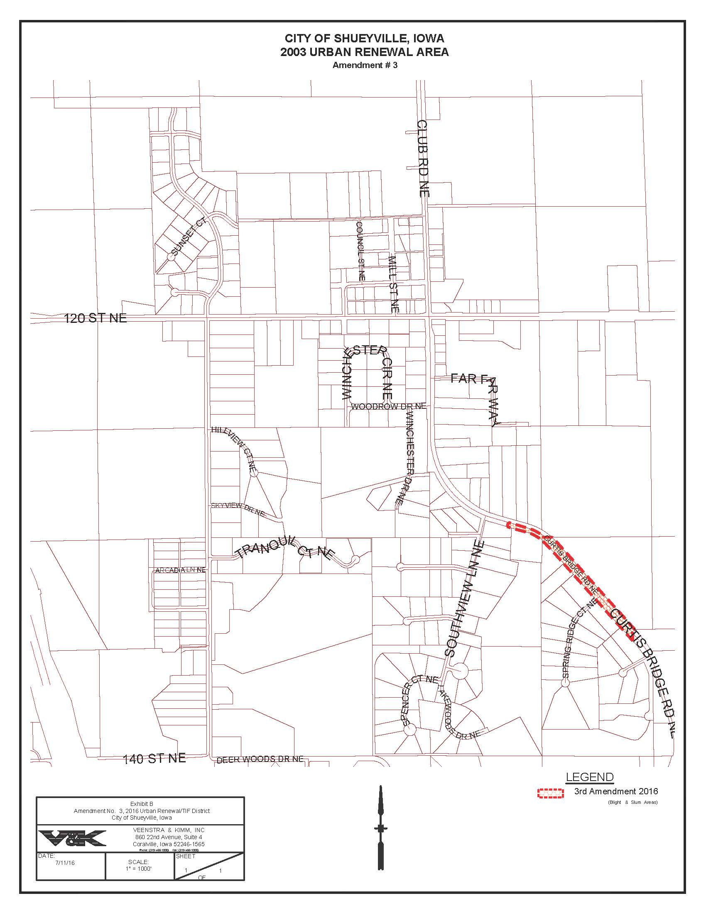
EXHIBIT C
